**Stateful and Stateless firewall**

**Note: Before Start this scenario, you must be configured VPC, Internet gateway and Nat gateway in your AWS Console. Then only it will work.**

1. **Stateful firewall**

**Type the public server IP in mstsc**

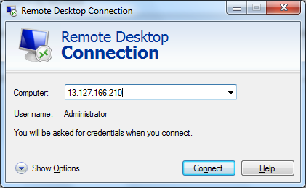

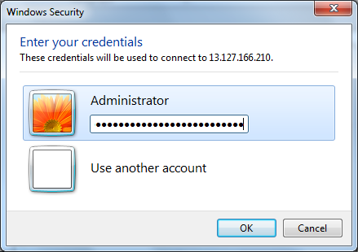

**Logged into the Public Server successfully.**

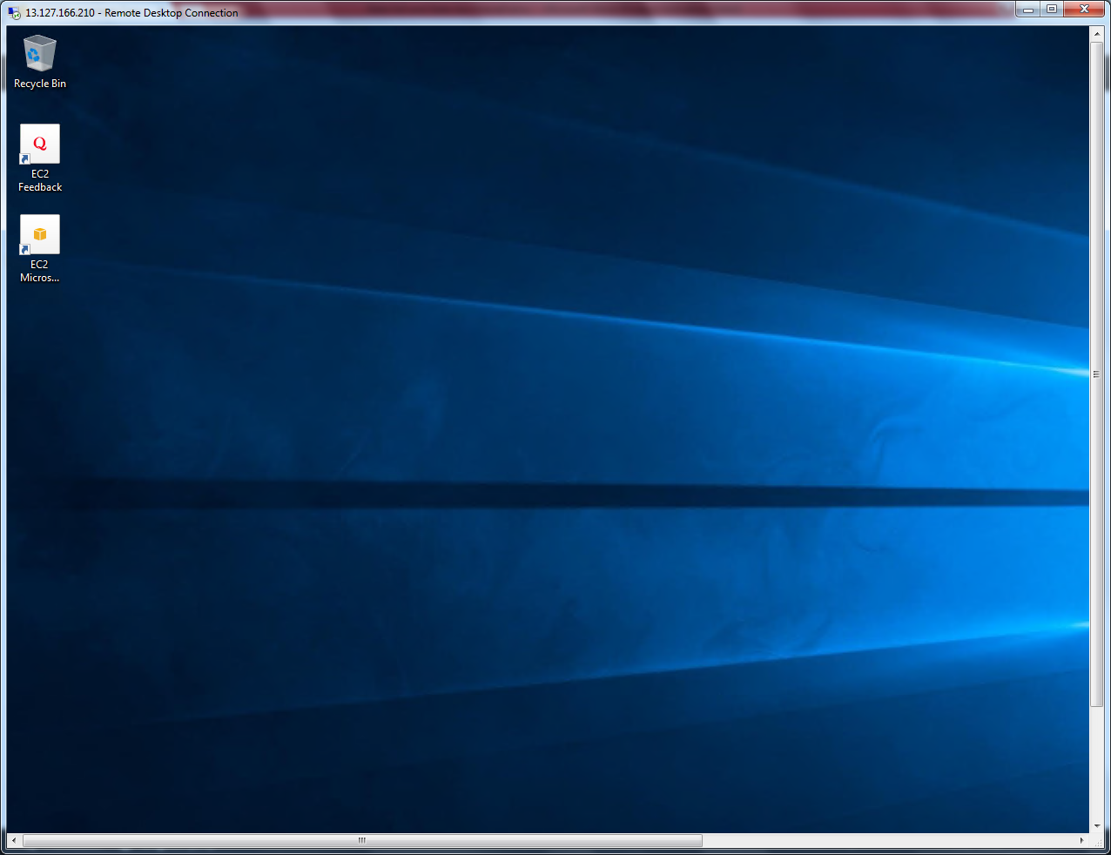

**Right click of start menu and click “Command prompt (Admin).**

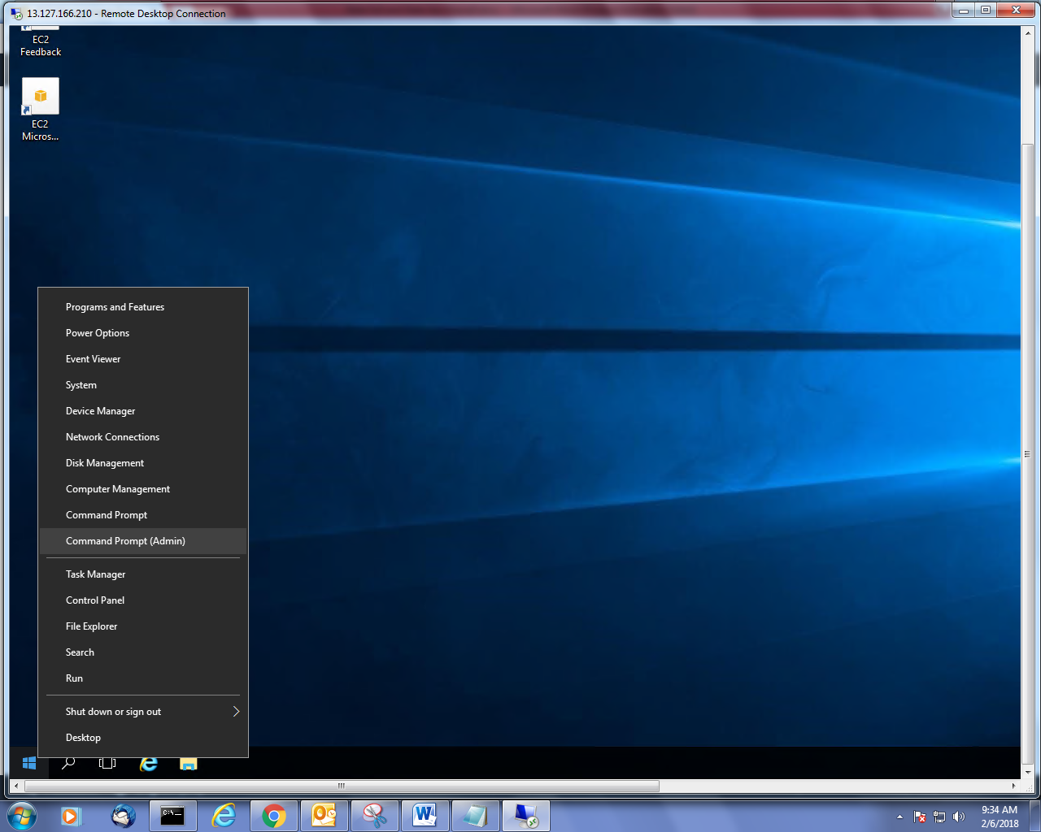

**Type “ipconfig” to get the ip address.**

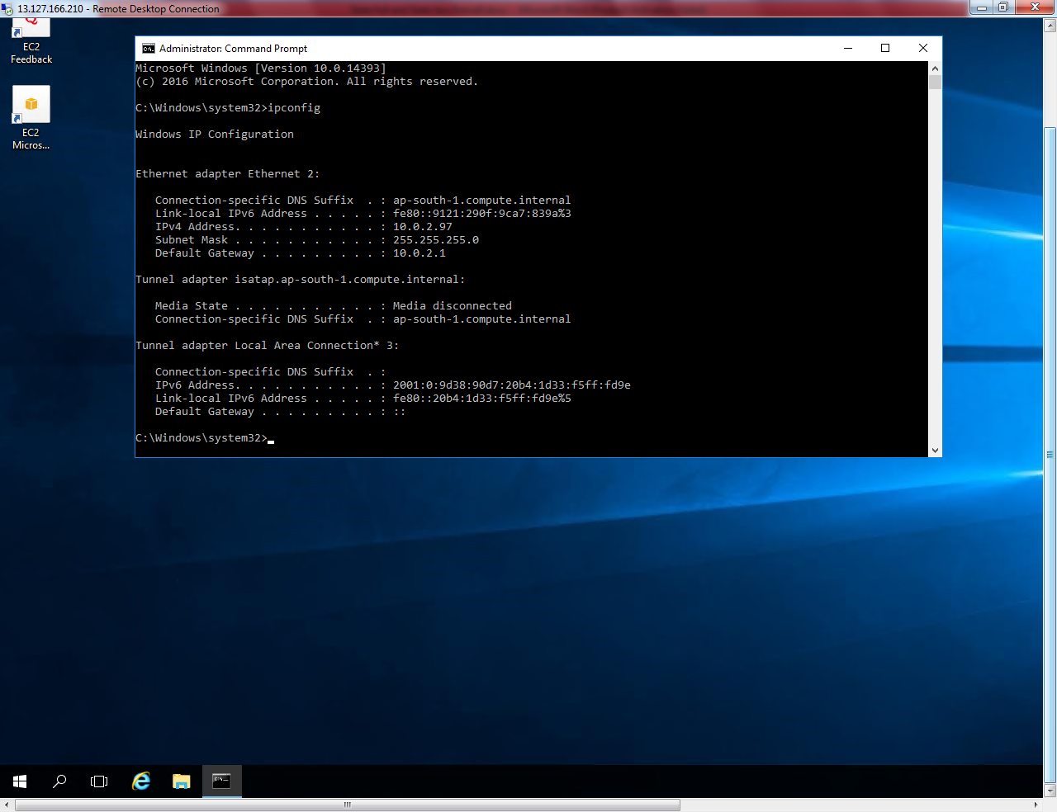

**You can able to access public network from public subnet.**

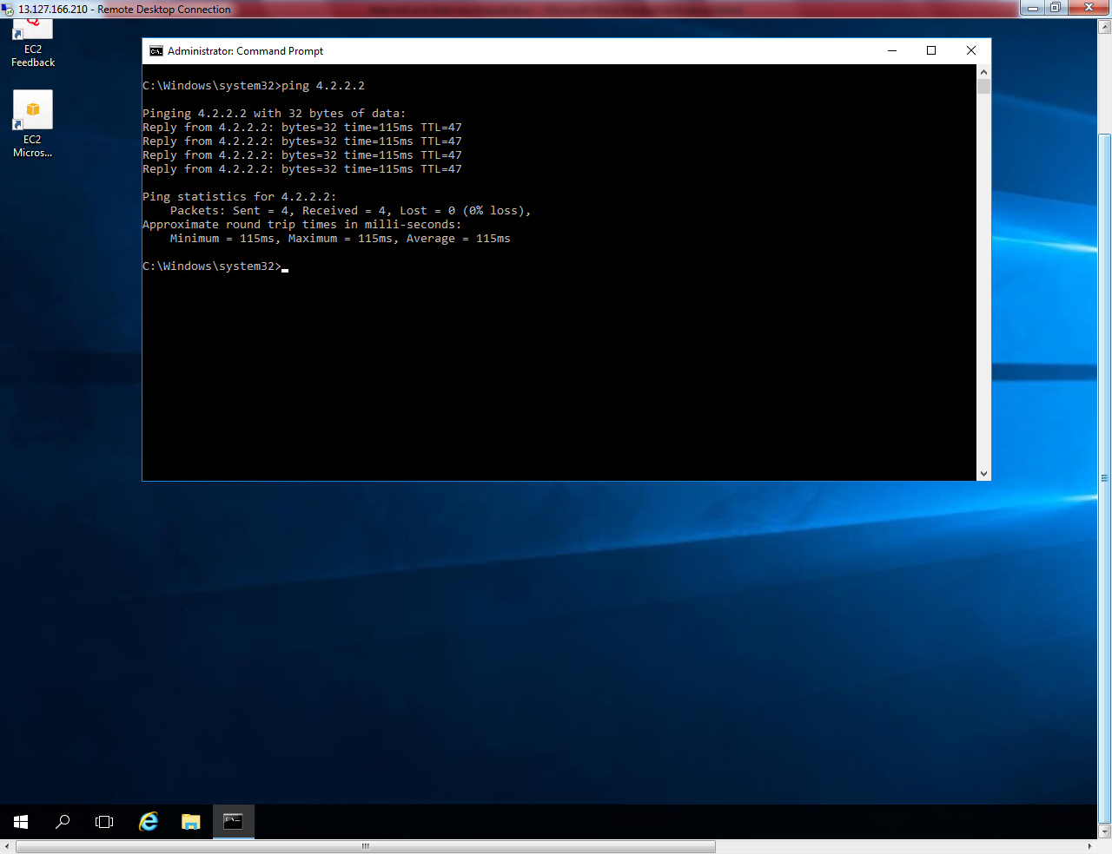

**Get the private IP address of Private subnet 10.0.1.45**

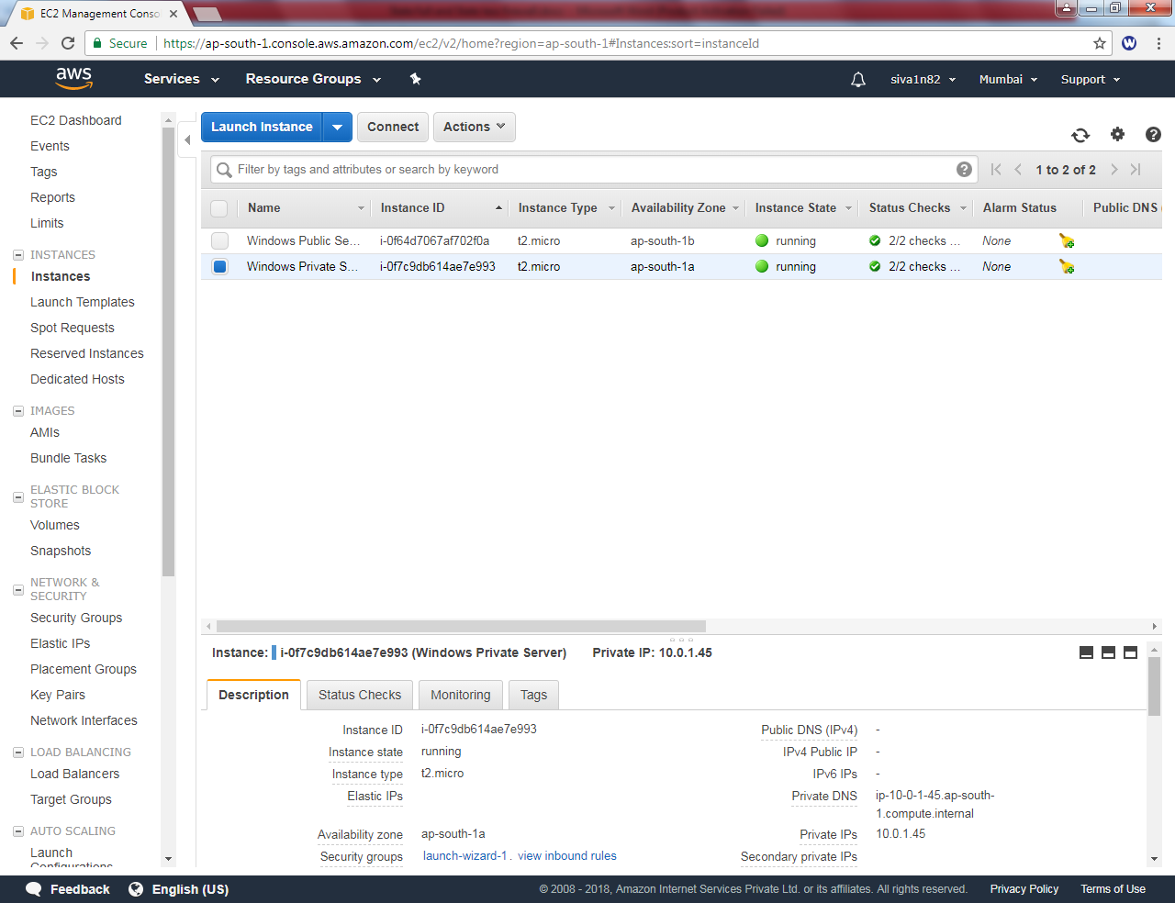

**Try to Ping 10.0.1.45, but getting request timed out. Because In security group of Private subnet allowed only RDP Port (3389) in inbound rules.**

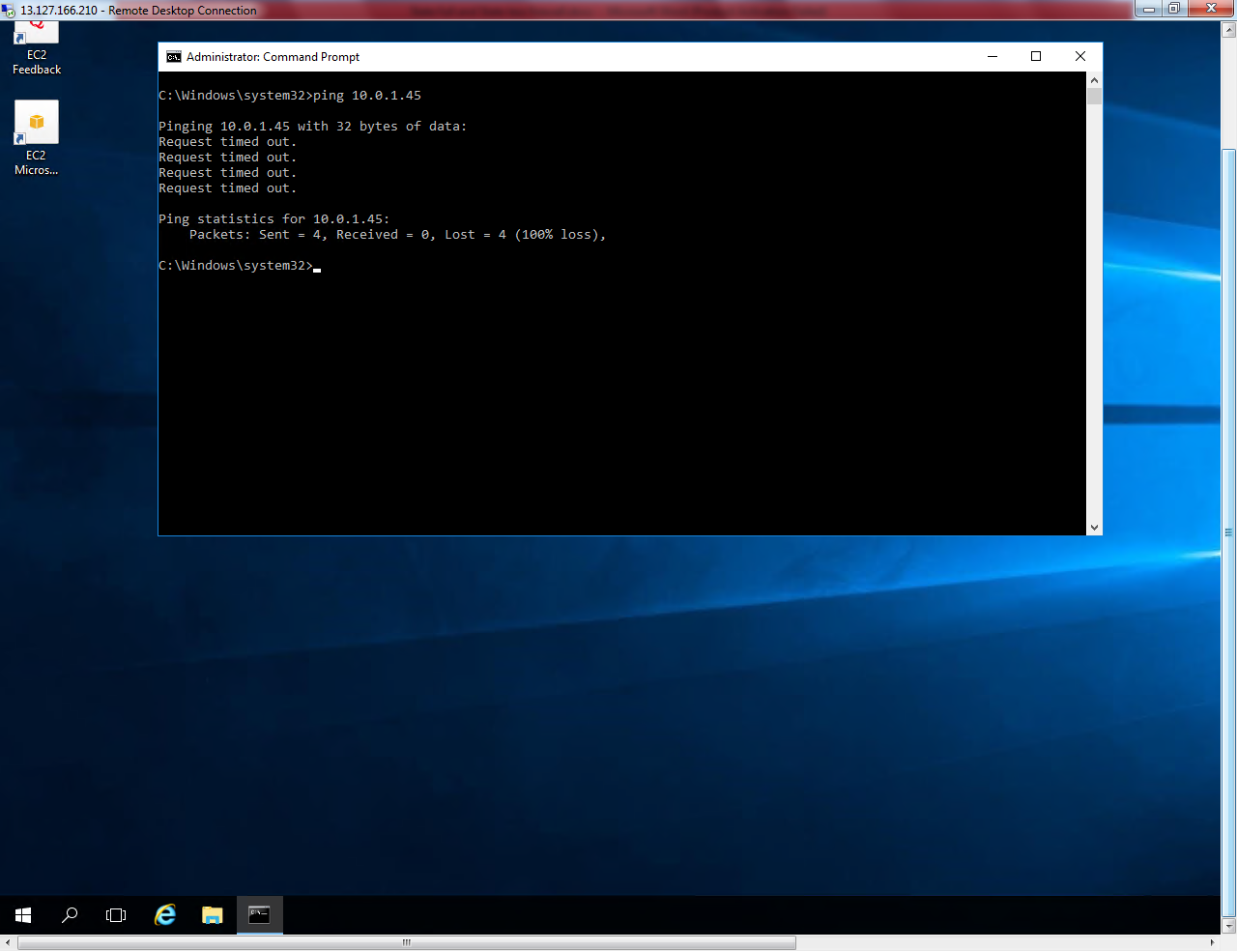

**Go to security group and select “Win Pvt Sec Group”.**

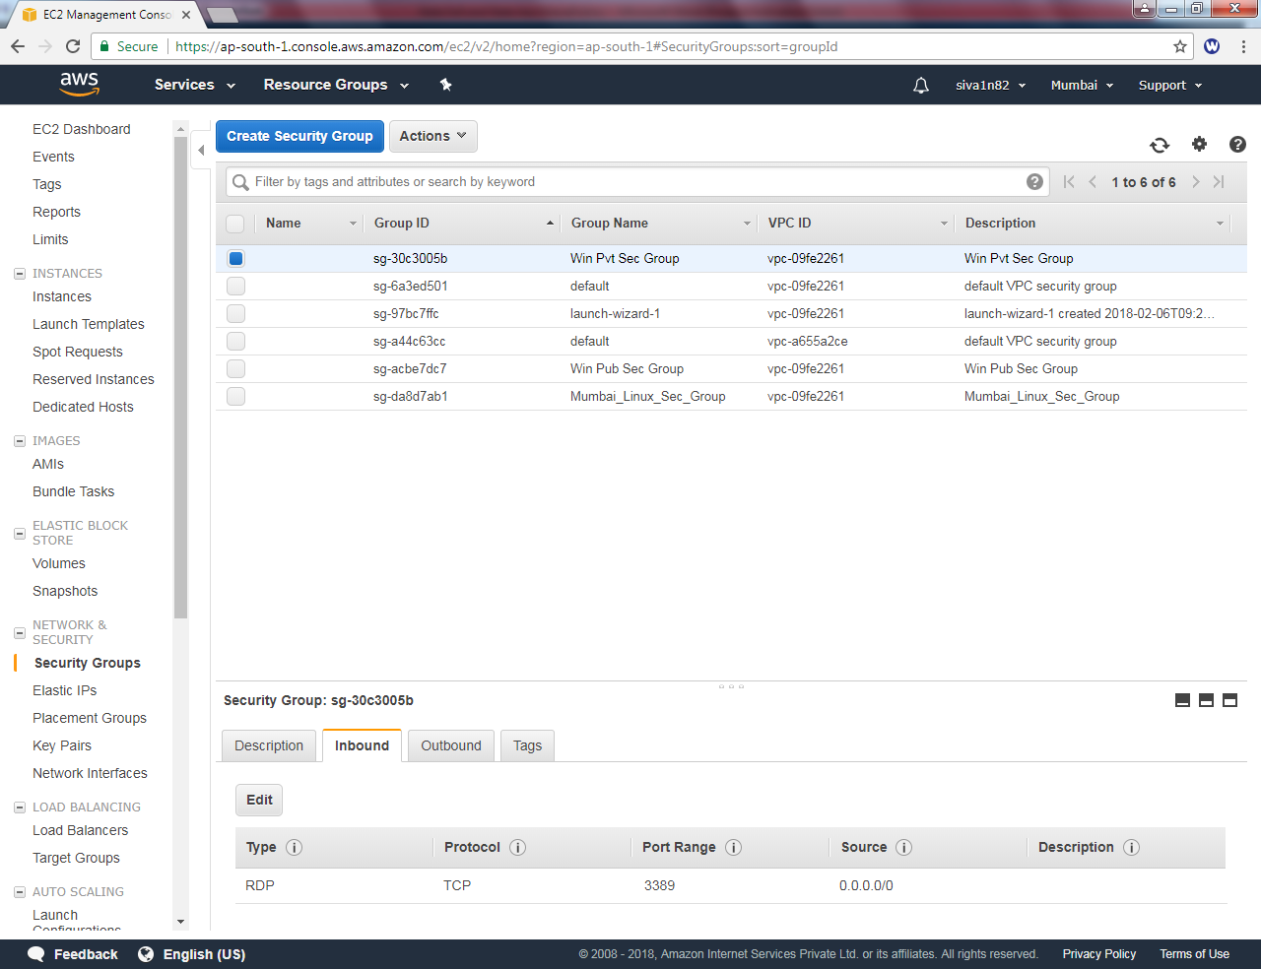

**Click “Add Rule”.**

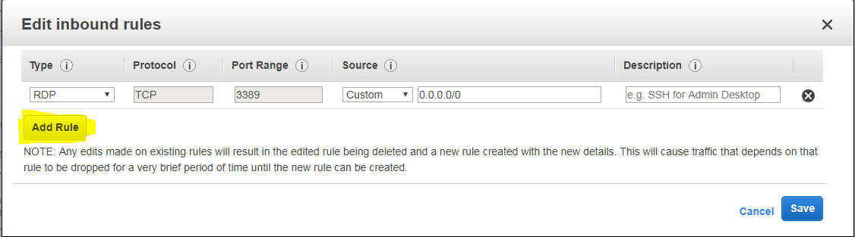

**Select “All ICMP “ traffic and source as 0.0.0.0/0**

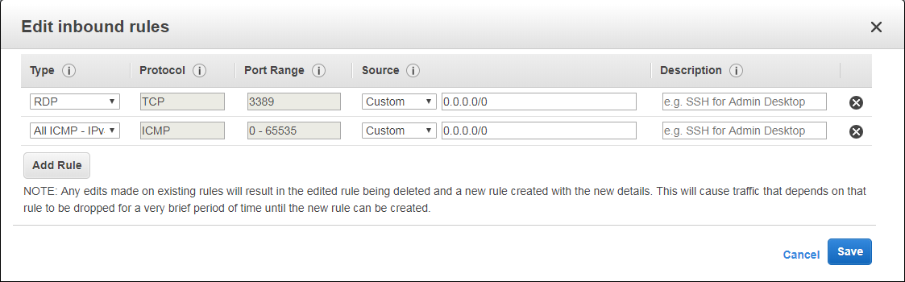

**Click “Save”.**

**Again try to ping 10.0.1.45 we are unable to ping because windows firewall on private subnet server need to be turned off.**

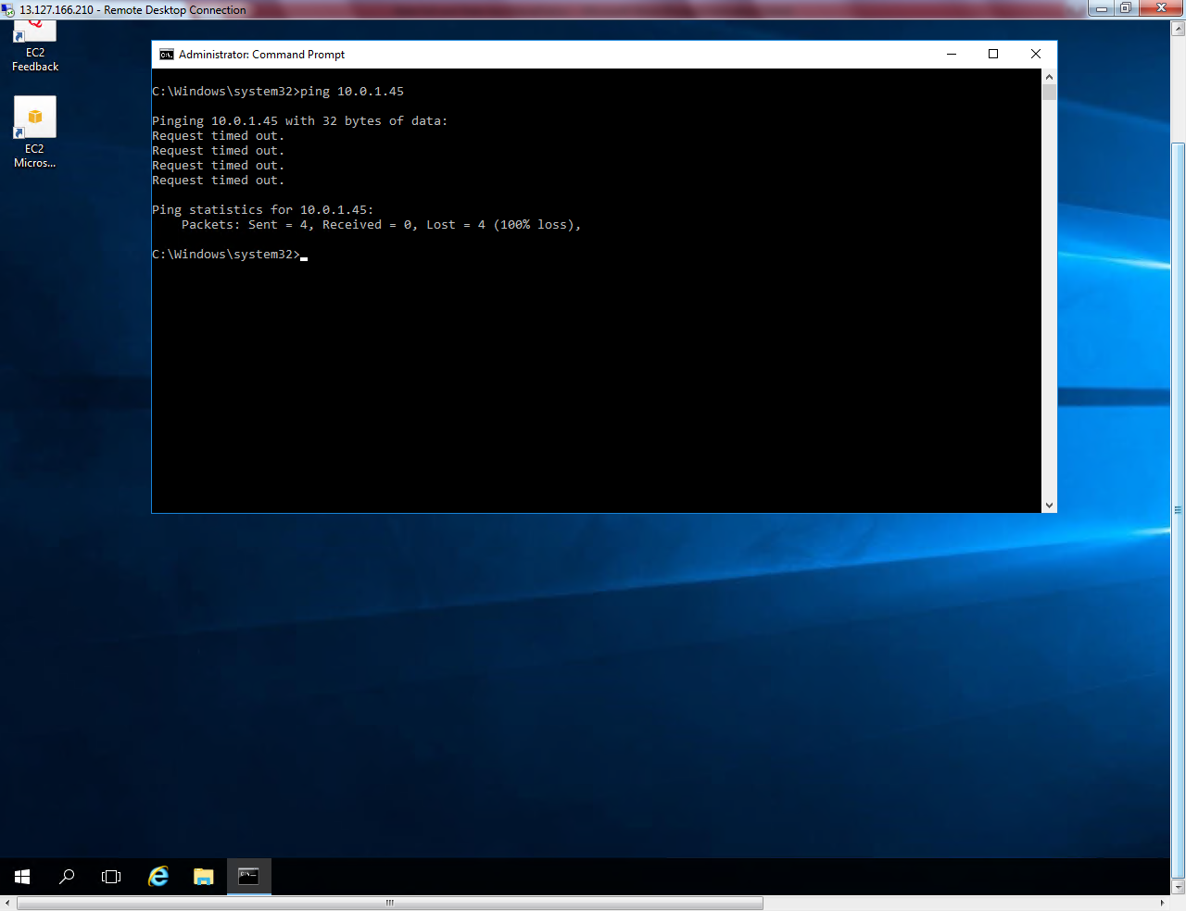

**Get the IP address of private server from AWS management console.**

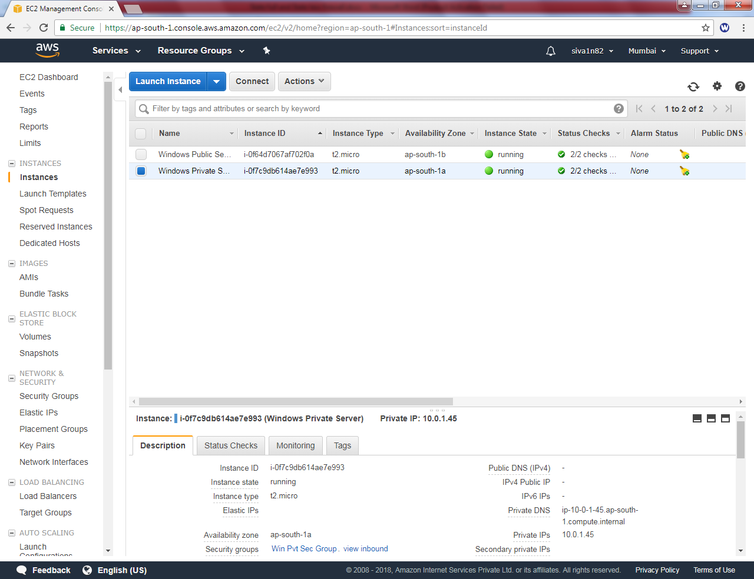

**Try to connect private subnet server from public subnet server (10.0.1.45).**

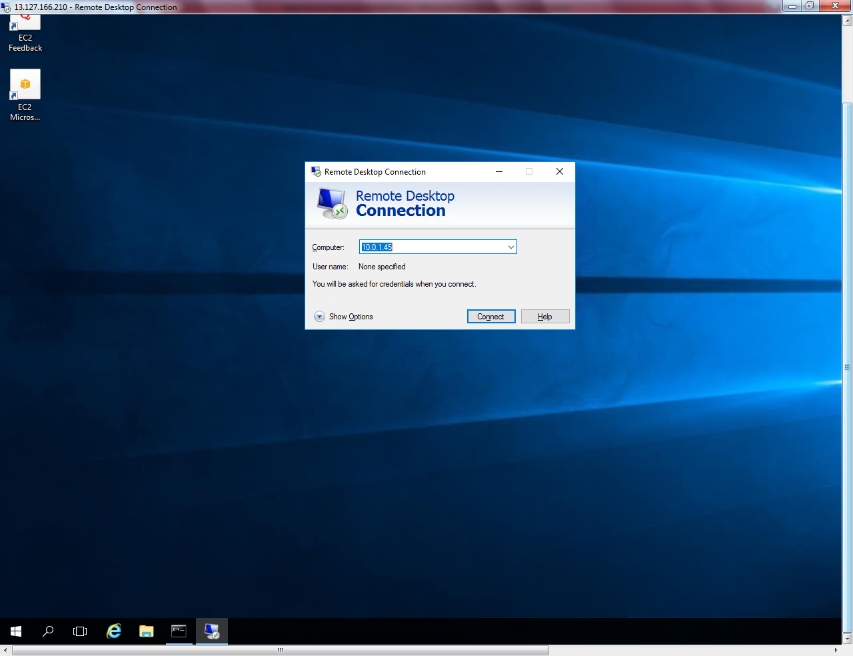

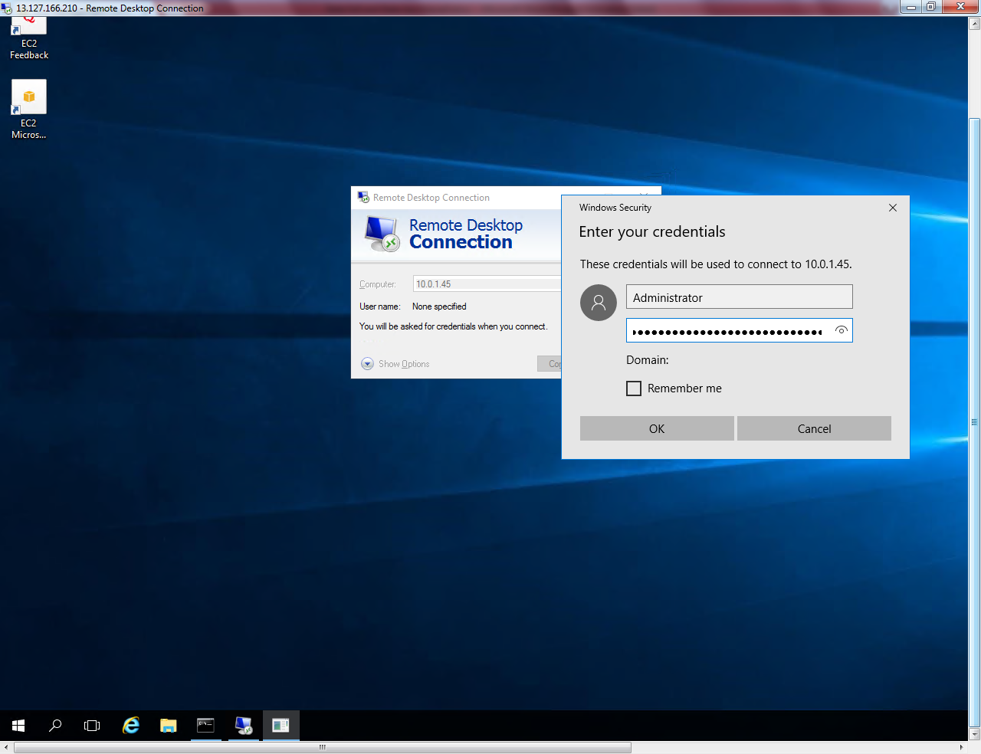

**Click “Yes” to continue.**

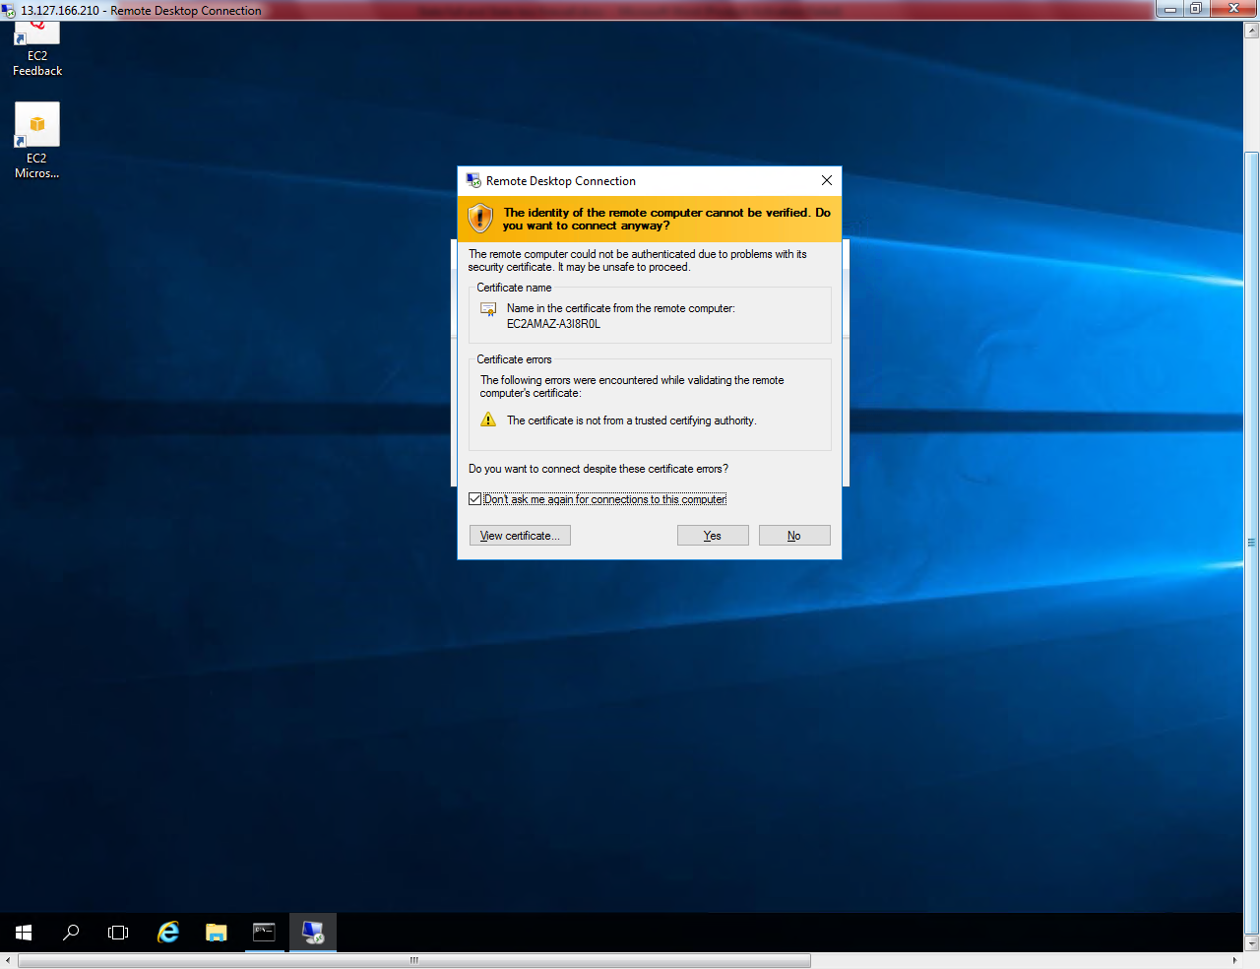

**Right click start menu and click “Command prompt (Admin)”**

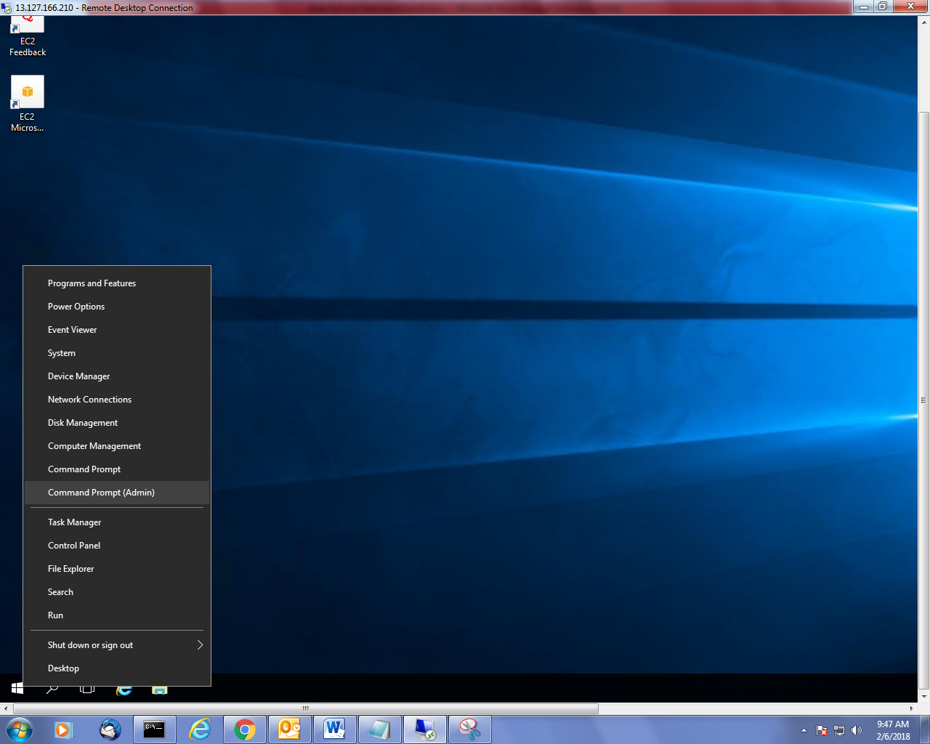

**Type ipconfig in Private server.**

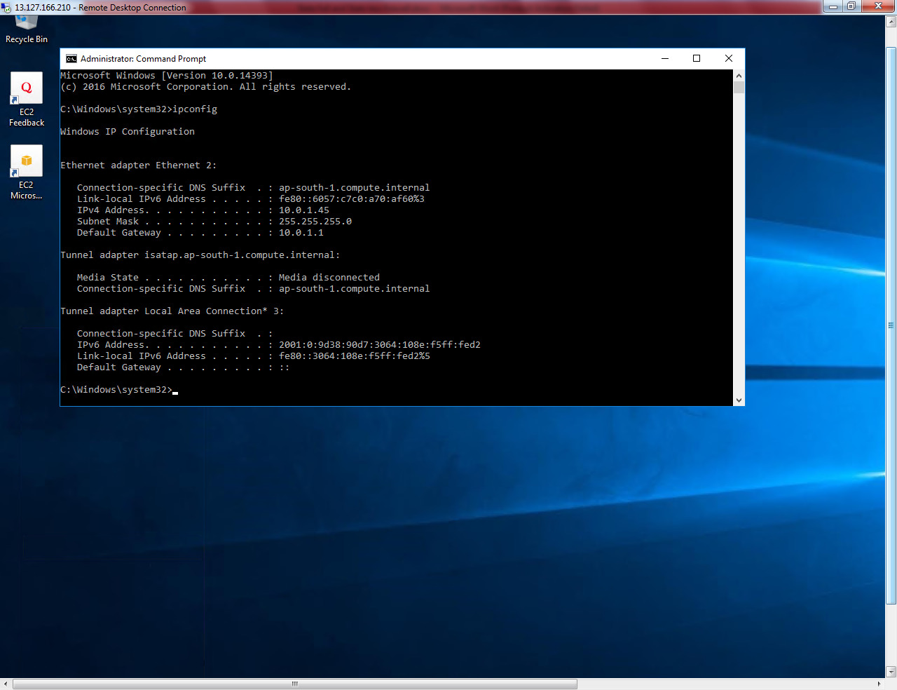

**Type google.com in private subnet server. We are able to connect internet from private subnet by using NAT gateway.**

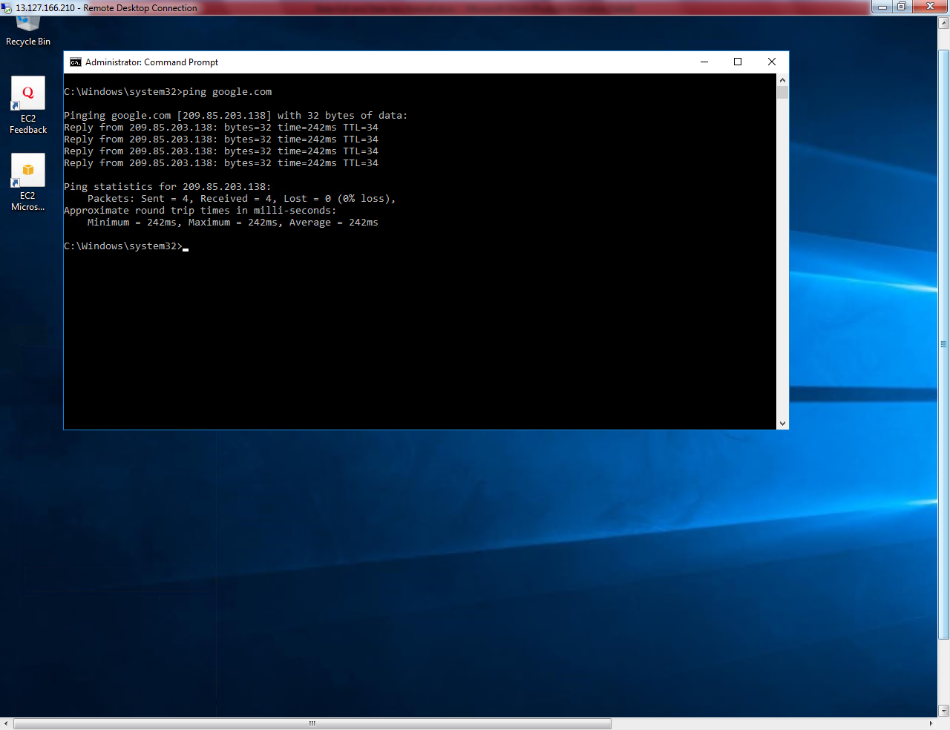

**Type Firewall.cpl**

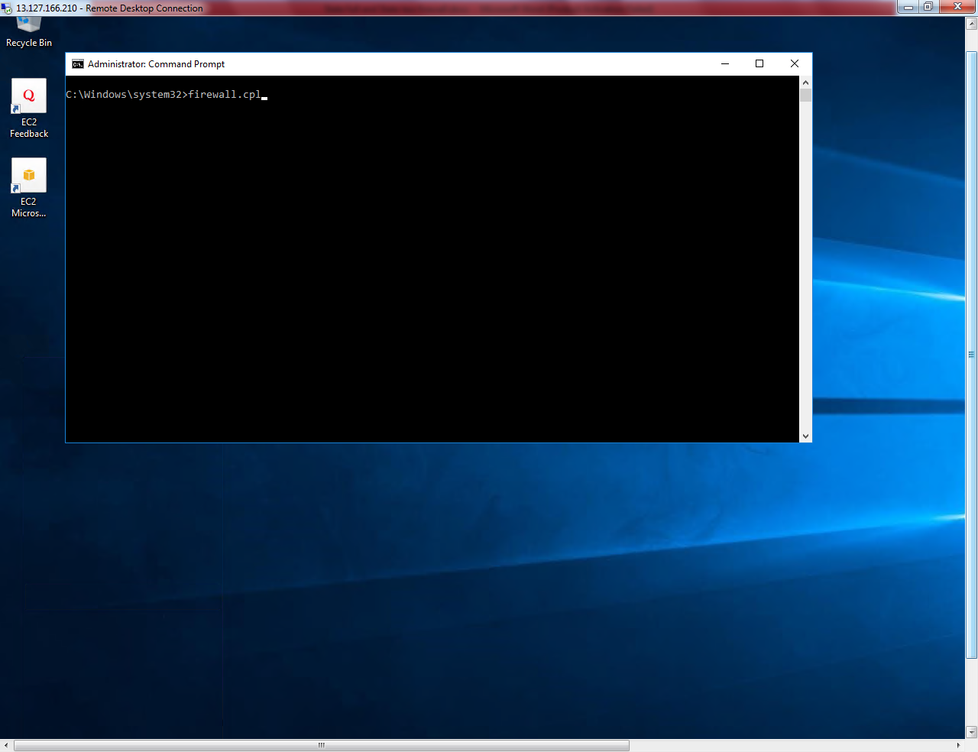

**Click “Turn Windows Firewall on or Off”.**

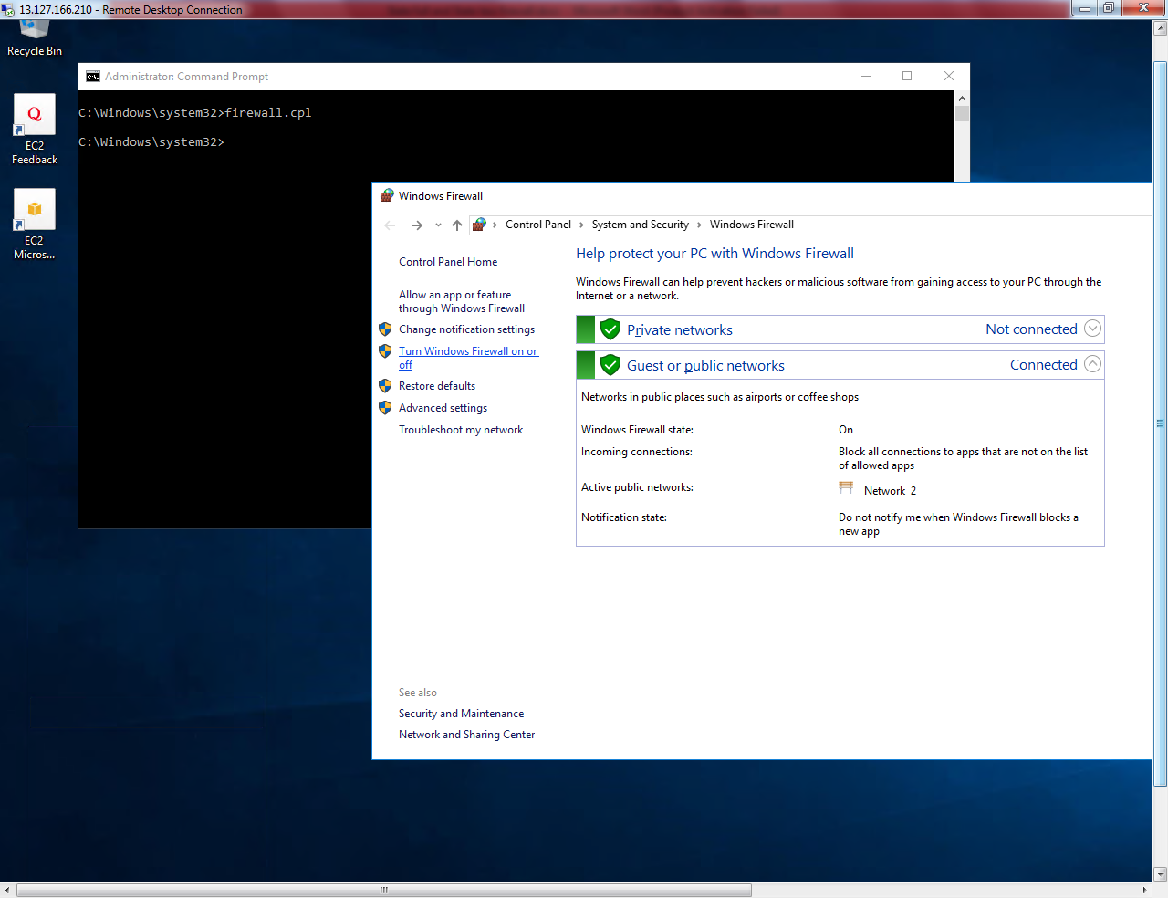

**Turn off windows firewall.**

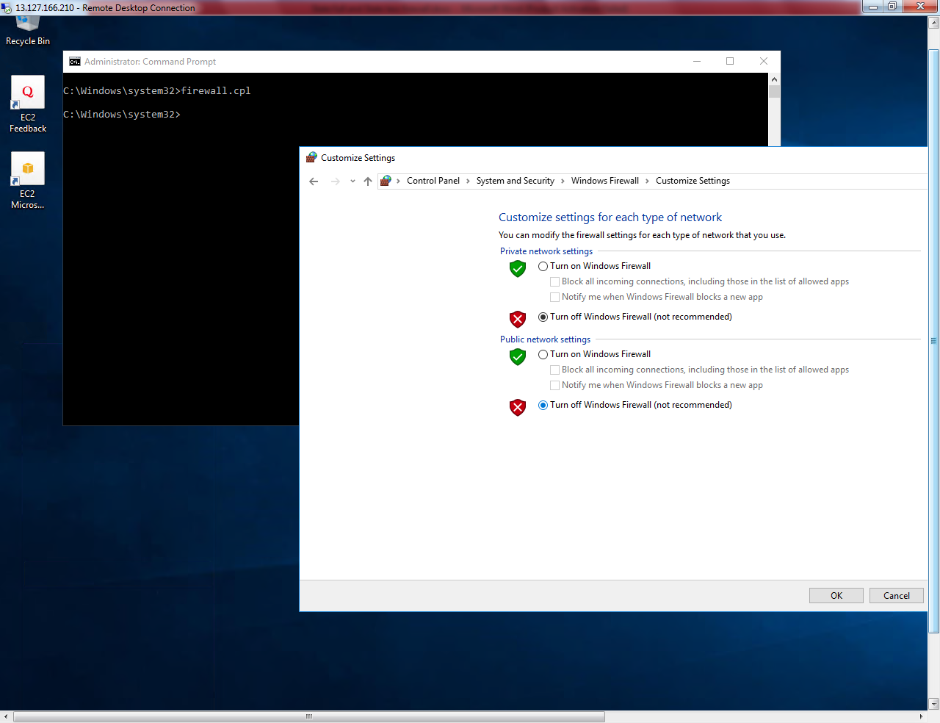

**Click ”Ok”.**

**Now try to ping 10.0.1.45 from Public subnet server. We can able to ping 10.0.1.45 from public subnet server.**

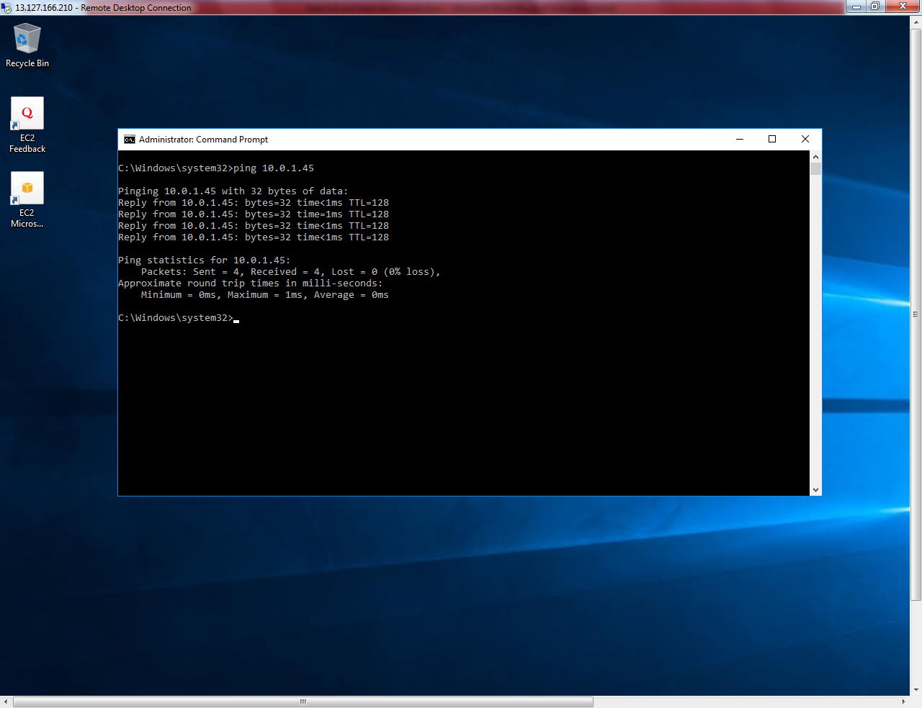

**Now I am going to remove out bound rule from Win Pvt Sub Server security group.**

**Click “Edit”.**

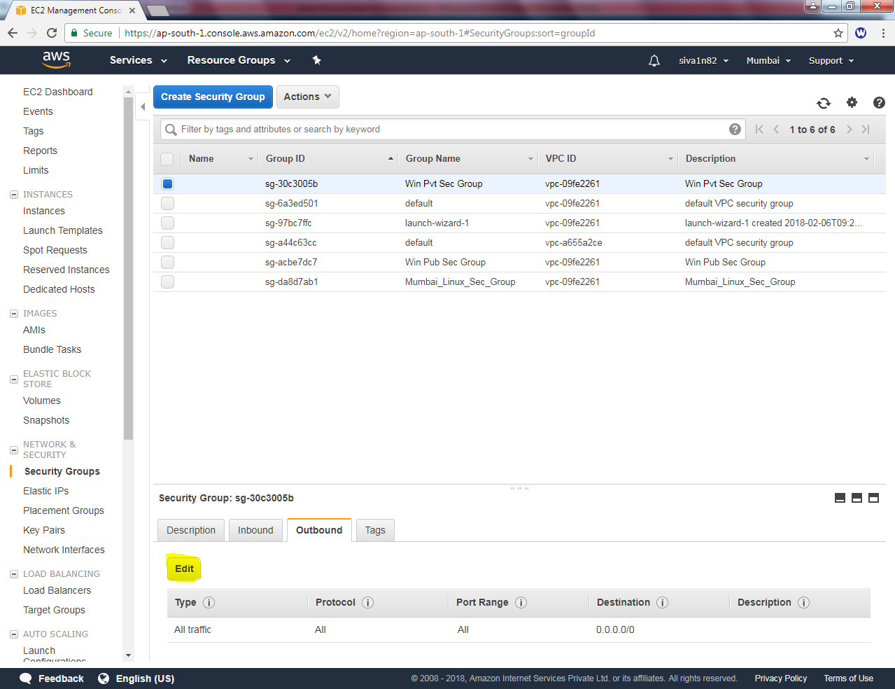

**Click “X” mark to remove.**

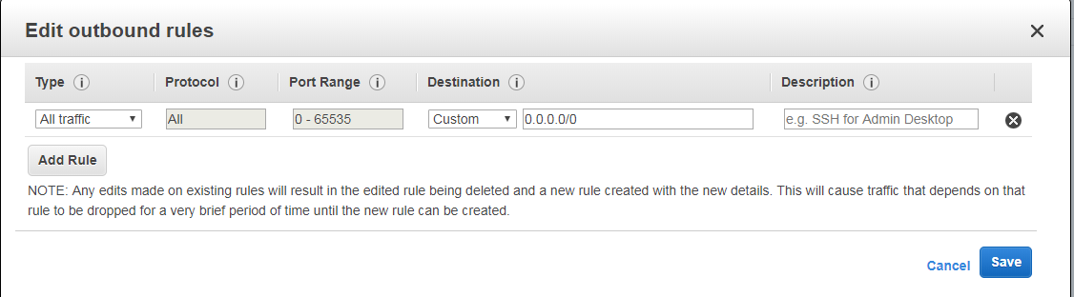

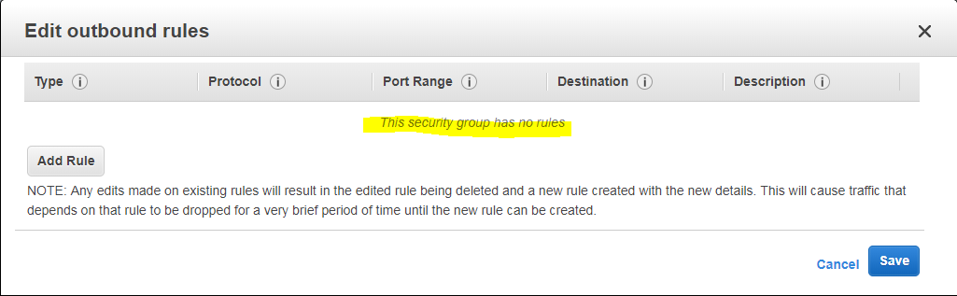

**Click Save.**

**Now we are able ping 10.0.1.45 because security group is stateful firewall. While we permit ICMP rule in inbound that will allow the same traffic / ICMP in outbound also. It does not require any permission in outbound rule. Hence, we can able to ping 10.0.1.45 from public subnet.**

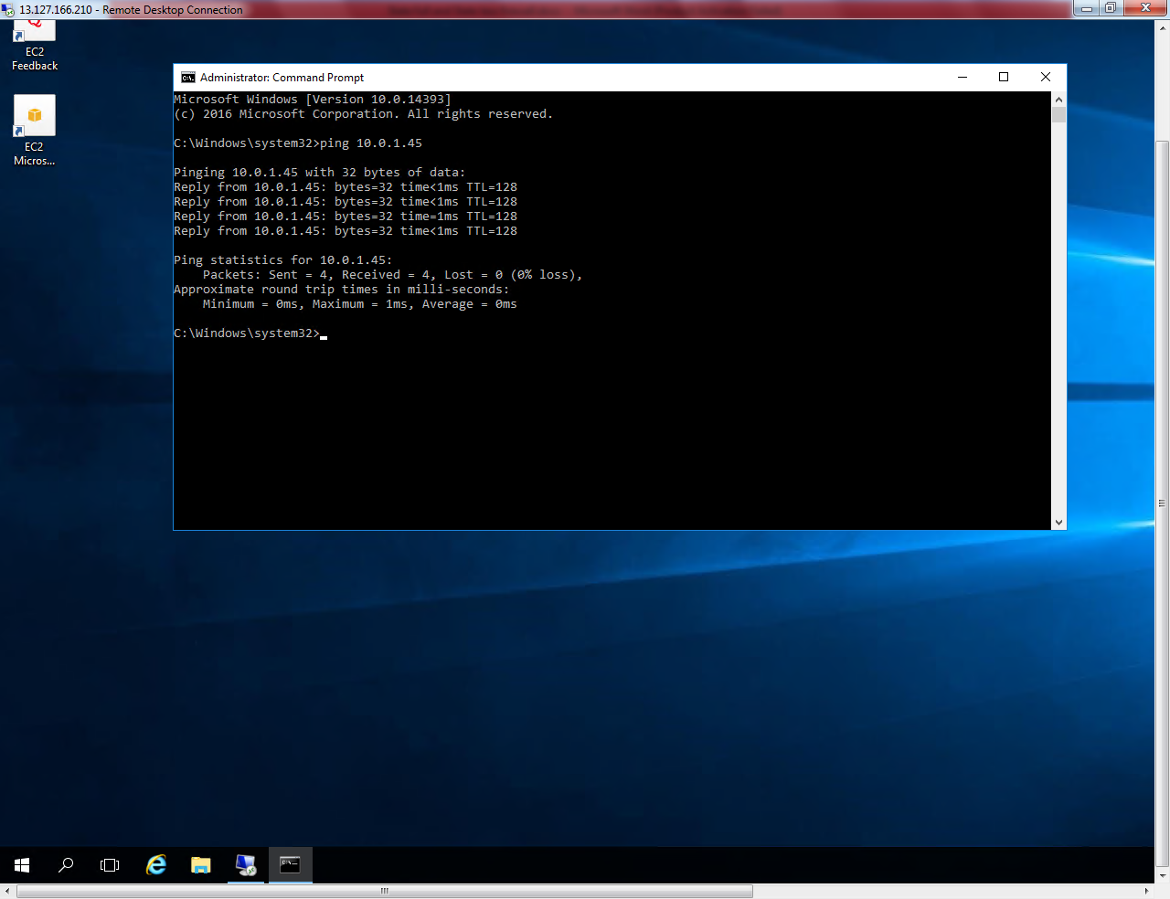

**Then restore the outbound rule as default.**

1. **Stateless Firewall**

**Goto “VPC” click Network ACLs.**

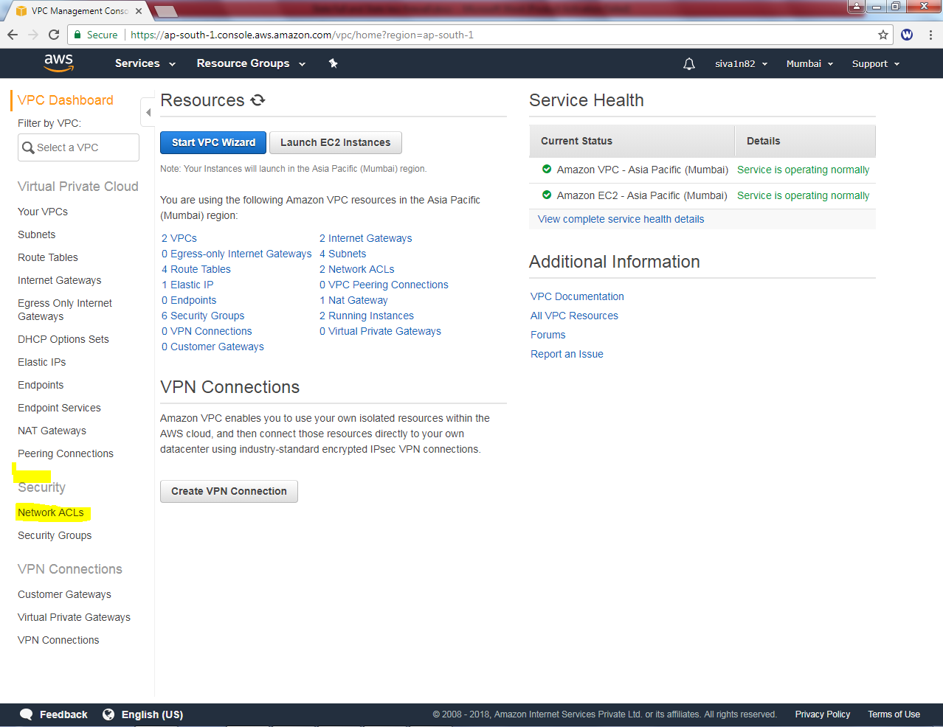

**Click “Edit”.**

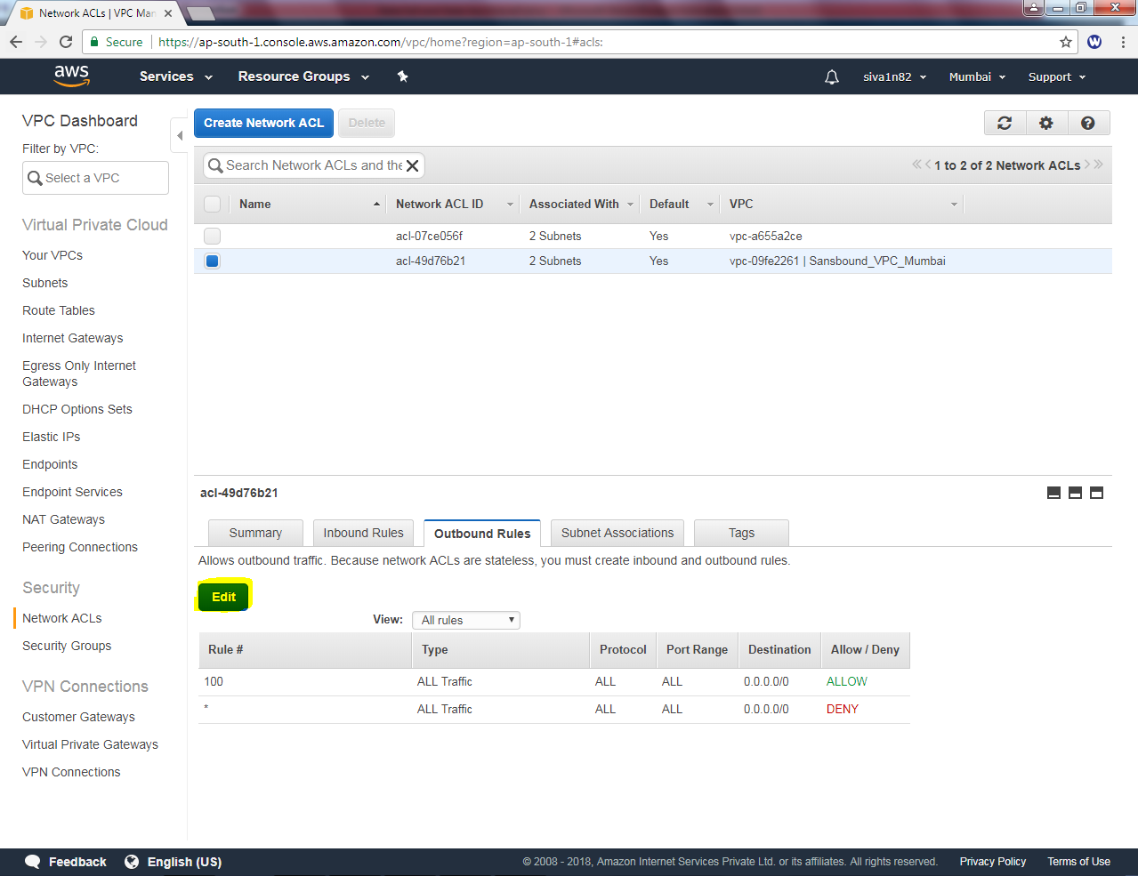

**Click “highlighted area” to remove ACL.**

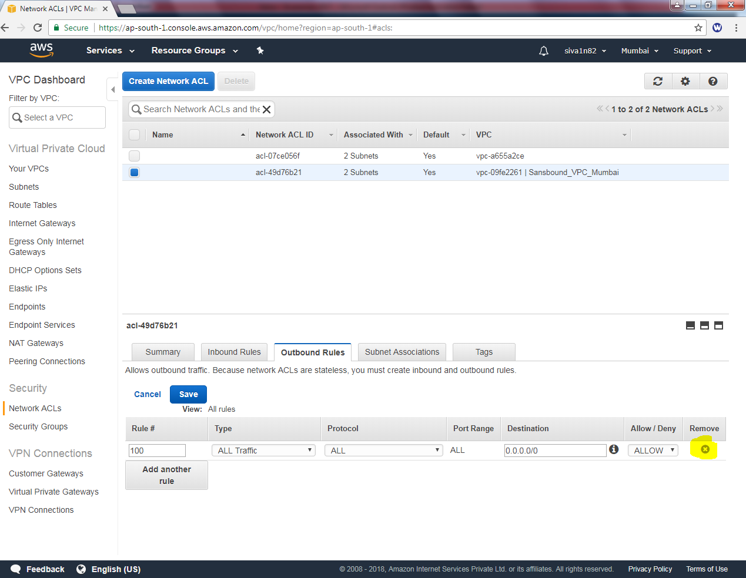

**Click “save’.**

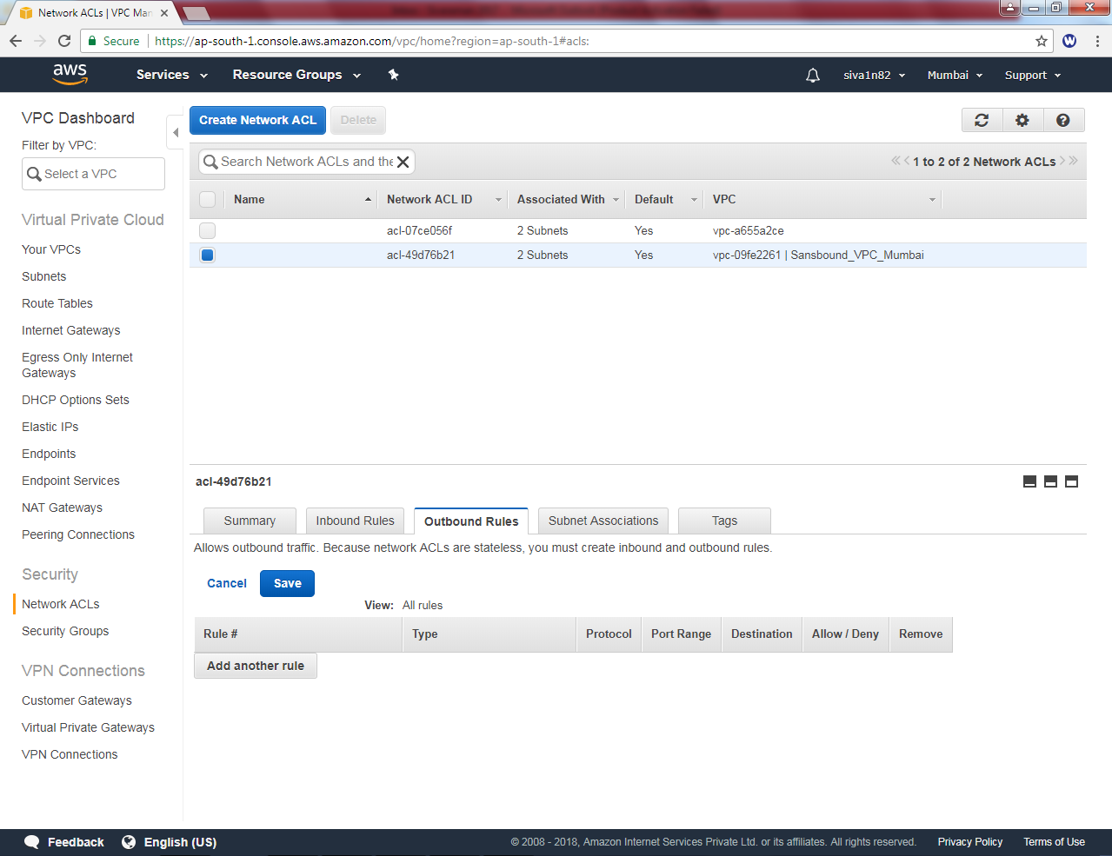

**My remote desktop connection on public server has been disconnected. Because Network ACL was stateless firewall. We have permitted RDP (3389) TCP port in inbound rule. But, we have removed All traffic from outbound rule. Hence our remote connection has been removed. We need to provide outbound rule with all traffic as allow.**

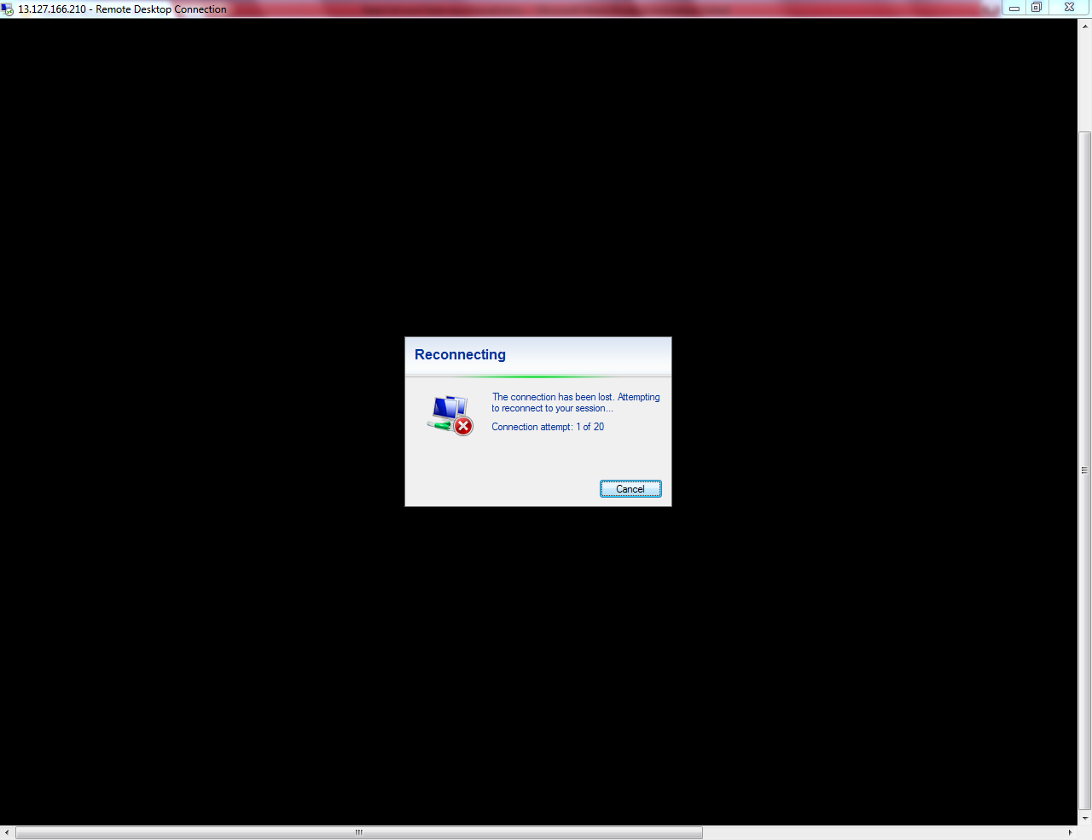

**We could not able able to remove * rule / deny from Network ACL.**

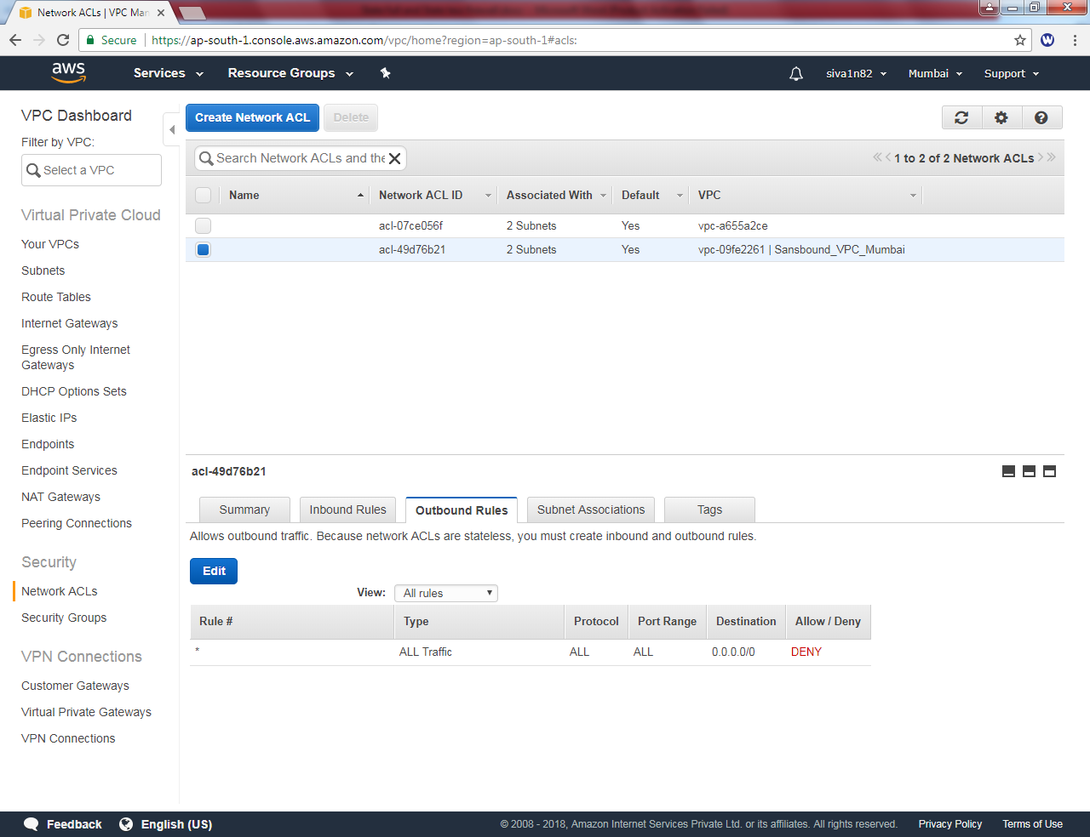

**Click “Edit”.**

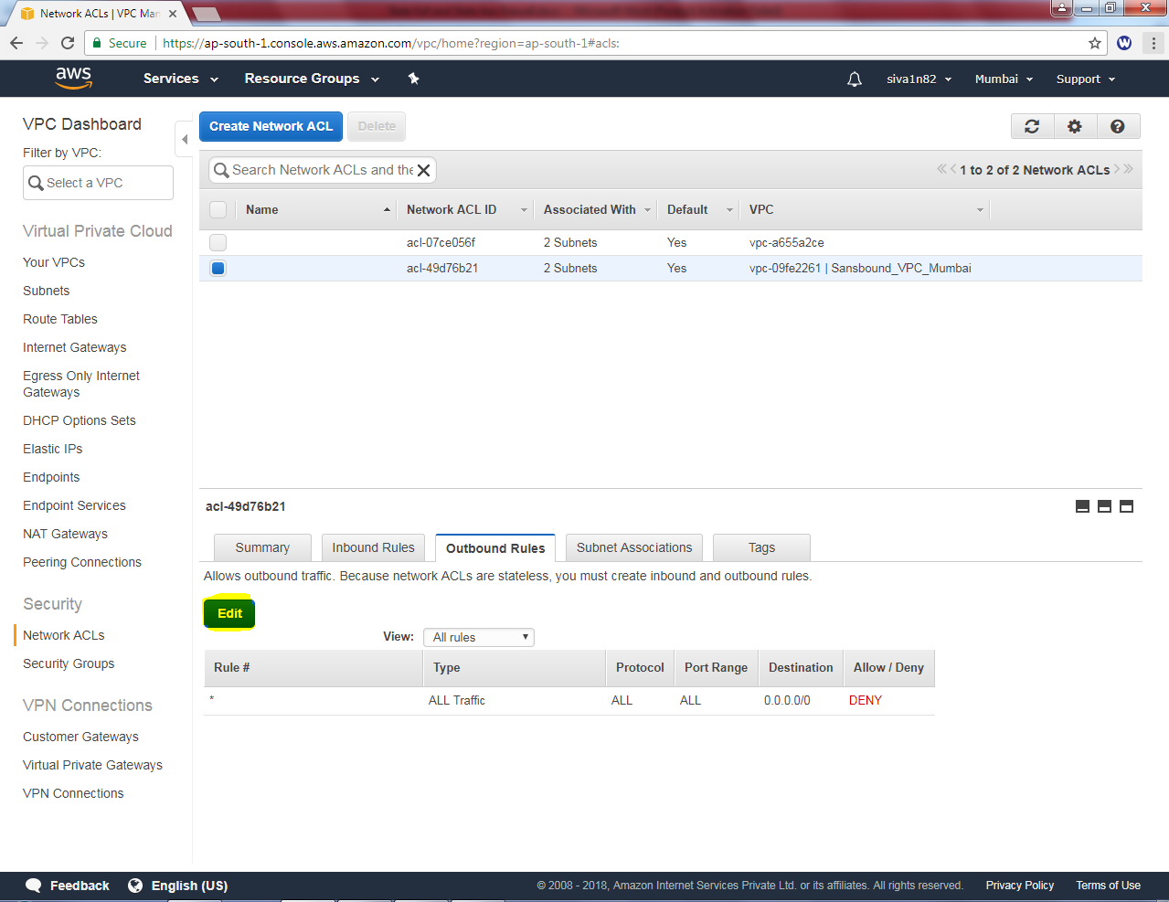

**Click “Add another rule”.**

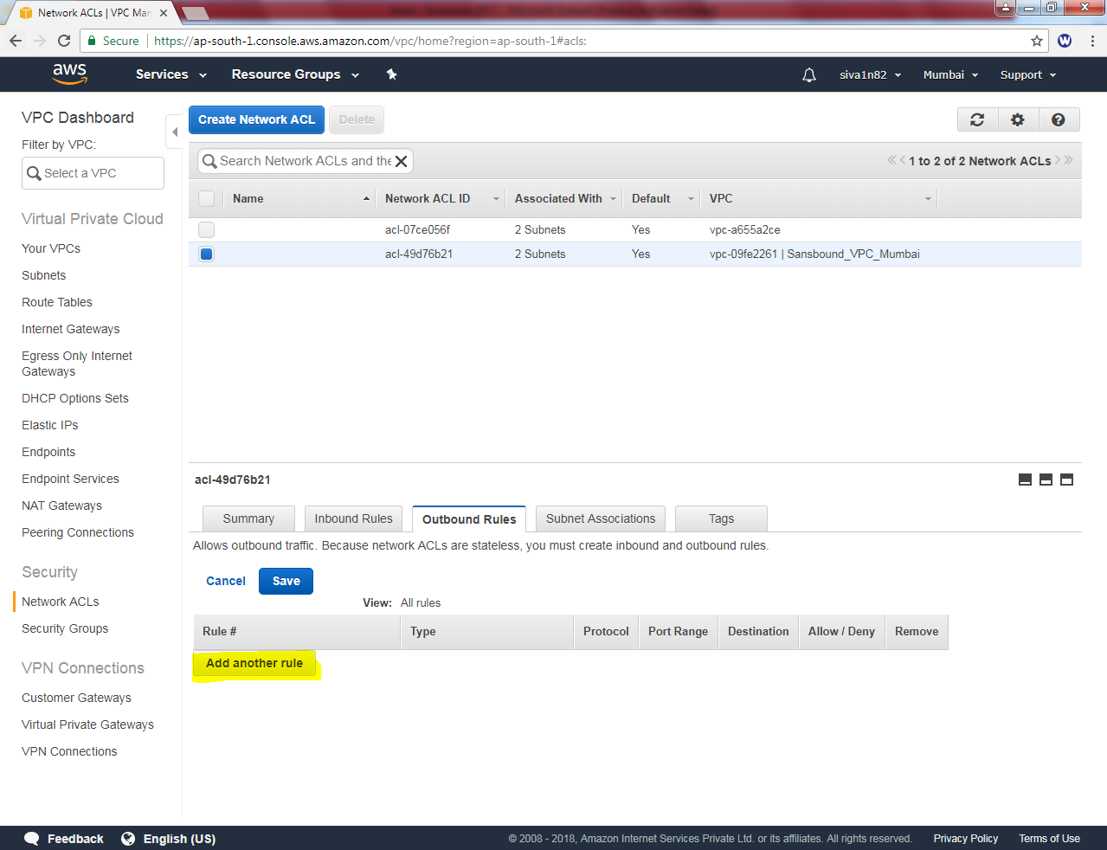

**Tyep ACL rule as : “100” Select type as “All traffic” destination as 0.0.0.0/0 and allow/ deny as allow.**

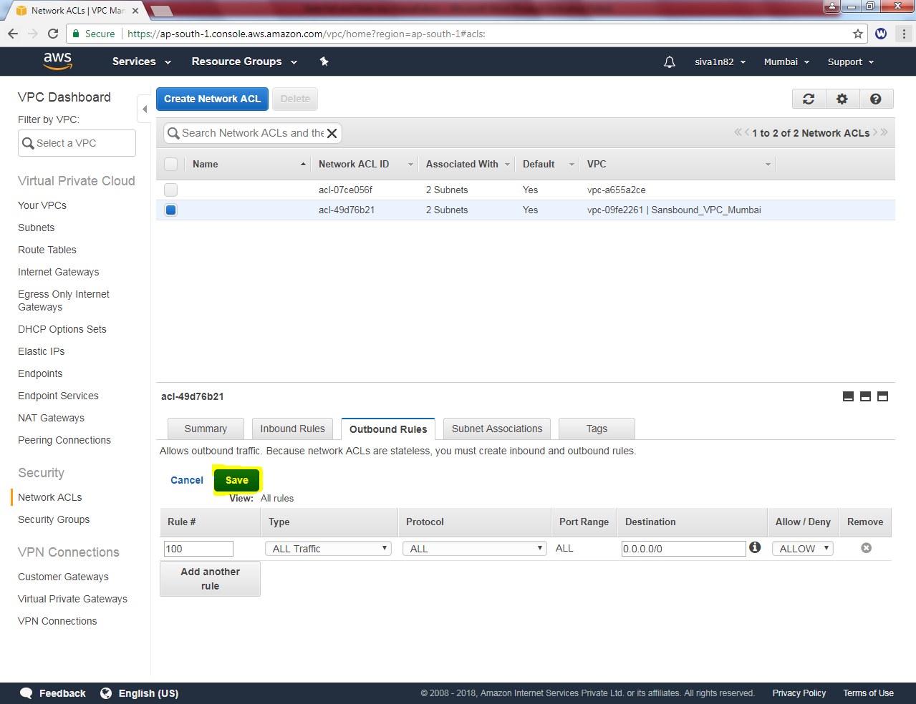

**Now we can able to get RDP for public server.**

